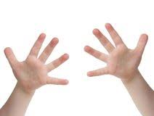

drie vier tien de vlieg

het wiel de mier de stier de knie

op een kier het riet het vliegtuig de muziek

EU IE

de brief de biet de dief ik ben ziek

de spier de riem de pier het dier

het nietje de fiets ik kijk zielig de wieg